FULL STACK WEB DEVELOPMENT PROJECT

NAME: ROHAN R. JADHAV

CLASS: MSC IT

COLLEGE: Ramnarain Ruia Autonomous College

PROJECT TOPIC:

Design a webpage using Bootstrap widgets for Angular.

INTRODUCTION

ANGULAR BOOTSTRAP:

Angular. bootstrap is **a function component in the core ng module** that is used for starting up the Angular application manually, which gives you more control over how you initialize your application.

We can create a new angular file by ng new (name)

**Installation**

We strongly recommend using [Angular CLI](https://cli.angular.io/) for setting up a new project. If you have an Angular ≥ 9 CLI project, you could simply use our schematics to add ng-bootstrap library to it.

Just run the following:

ng add @ng-bootstrap/ng-bootstrap

It will install ng-bootstrap for the default application specified in your angular.json. If you have multiple projects and you want to target a specific application, you could specify the --project option

ng add @ng-bootstrap/ng-bootstrap --project myProject.

#### Manual installation

If you prefer not to use schematics or want to add ng-bootstrap to an older project, you'll need to do the following:

* Add bootstrap and @ng-bootstrap/ng-bootstrap dependencies from npm
* Install the @angular/localize polyfill
* Add bootstrap CSS/SCSS to your project (no javascript is required)
* Import NgbModule or any other component module like NgbPaginationModule in your application.

After installing all the above package we can start our coding in app.component.html and other components

PROGRAMS AND SOURCE CODE:

First we code in app.component.html:

<nav class="navbar navbar-expand-lg navbar-light bg-success">

<div class="container-fluid">

<a class="navbar-brand" href="#">Navbar</a>

<button class="navbar-toggler" type="button" data-bs-toggle="collapse" data-bs-target="#navbarSupportedContent" aria-controls="navbarSupportedContent" aria-expanded="false" aria-label="Toggle navigation">

<span class="navbar-toggler-icon"></span>

</button>

<div class="collapse navbar-collapse" id="navbarSupportedContent">

<ul class="navbar-nav me-auto mb-2 mb-lg-0">

<li class="nav-item">

<a class="nav-link active" aria-current="page" href="#">Home</a>

<a class="nav-item nav-link" routerLink="/login">Product</a>

<a class="nav-item nav-link" routerLink="/register">DASHBOARD</a>

</li>

<li class="nav-item">

<a class="nav-link" href="#">Link</a>

</li>

<li class="nav-item dropdown">

<a class="nav-link dropdown-toggle" href="#" id="navbarDropdown" role="button" data-bs-toggle="dropdown" aria-expanded="false">

Dropdown

</a>

<ul class="dropdown-menu" aria-labelledby="navbarDropdown">

<li><a class="dropdown-item" href="#">Action</a></li>

<li><a class="dropdown-item" href="#">Another action</a></li>

<li><hr class="dropdown-divider"></li>

<li><a class="dropdown-item" href="#">Something else here</a></li>

</ul>

</li>

<li class="nav-item">

<a class="nav-link disabled">Disabled</a>

</li>

</ul>

<form class="d-flex">

<input class="form-control me-2" type="search" placeholder="Search" aria-label="Search">

<button class="btn btn-outline-success" type="submit">Search</button>

</form>

</div>

</div>

</nav>

<router-outlet></router-outlet>

Then we create a home component by ng generate home component.

[Home.component.html](http://Home.component.html):

<div class="jumbotron">

<div class="container">

<h1 class="display-3">CAR SHOWROOM</h1>

<p>This is a car showcase website where you can see your favorite car and get information about their interiors and designs</p>

<p><a class="btn btn-primary btn-lg" href="https://www.w3schools.com/" role="button">Learn more &raquo;</a></p>

</div>

</div>

<div class="container">

<div class="row">

<div class="col-sm">

<a href="/friends"

role="button"

class="btn btn-outline-primary btn-lg btn-block text-center">

<span><i class="fa fa-users"></i></span>

<br>C32

</a>

</div>

<div class="col-sm">

<a href="/friends"

role="button"

class="btn btn-outline-primary btn-lg btn-block text-center">

<span><i class="fa fa-mobile"></i></span>

<br>G44

</a>

</div>

<div class="col-sm">

<a href="/friends"

role="button"

class="btn btn-outline-primary btn-lg btn-block text-center">

<span><i class="fa fa-users"></i></span>

<br>LAM33

</a>

</div>

<div class="col-sm">

<a href="/friends"

role="button"

class="btn btn-outline-primary btn-lg btn-block text-center">

<span><i class="fa fa-users"></i></span>

<br>USI33

</a>

</div>

<div class="col-sm">

<a href="/friends"

role="button"

class="btn btn-outline-primary btn-lg btn-block text-center">

<span><i class="fa fa-users"></i></span>

<br>FFE5

</a>

</div>

</div>

<div class="row">

<div class="col-sm">

<div class="card" style="width: 18rem;">

<img width="200px" height="160px" src="/assets/images/4.jpeg" class="card-img-top">

<div class="card-body">

<h5 class="card-title">Bali Beach</h5>

<p class="card-text">Some quick example text's content.</p>

<a href="#" class="btn btn-primary">View Models</a>

</div>

</div>

</div>

<div class="col-sm">

<div class="card" style="width: 18rem;">

<img width="200px" height="160px" src="/assets/images/3.png" class="card-img-top">

<div class="card-body">

<h5 class="card-name">Greenland Hills</h5>

<p class="card-text">Some quick example text's content.</p>

<a href="#" class="btn btn-primary">View Models</a>

</div>

</div>

</div>

<div class="col-sm">

<div class="card" style="width: 18rem;">

<img width="200px" height="160px" src="/assets/images/2.webp" class="card-img-top">

<div class="card-body">

<h5 class="card-title">Canada Hills</h5>

<p class="card-text">Some quick example text's content.</p>

<a href="#" class="btn btn-primary">View Models</a>

</div>

</div>

</div>

<div class="col-sm">

<div class="card" style="width: 18rem;">

<img width="200px" height="160px" src="/assets/images/1.jpg" class="card-img-top">

<div class="card-body">

<h5 class="card-title">Nigeria falls</h5>

<p class="card-text">Some quick example text's content.</p>

<a href="#" class="btn btn-primary">View Models</a>

</div>

</div>

</div>

</div>

</div>

Then we create another login component for next page.

Login.component.html:

<h1 class="navbar navbar-expand-lg navbar-light bg-primary">Product Page</h1>

<nav class="navbar navbar-expand-lg navbar-light bg-success">

<div class="container-fluid">

<a class="navbar-brand" href="#">Navbar</a>

<button class="navbar-toggler" type="button" data-bs-toggle="collapse" data-bs-target="#navbarSupportedContent" aria-controls="navbarSupportedContent" aria-expanded="false" aria-label="Toggle navigation">

<span class="navbar-toggler-icon"></span>

</button>

<div class="collapse navbar-collapse" id="navbarSupportedContent">

<ul class="navbar-nav me-auto mb-2 mb-lg-0">

<li class="nav-item">

<a class="nav-link active" aria-current="page" href="#">Home</a>

</li>

<li class="nav-item">

<a class="nav-link" href="#">Link</a>

</li>

<li class="nav-item dropdown">

<a class="nav-link dropdown-toggle" href="#" id="navbarDropdown" role="button" data-bs-toggle="dropdown" aria-expanded="false">

Dropdown

</a>

<ul class="dropdown-menu" aria-labelledby="navbarDropdown">

<li><a class="dropdown-item" href="#">Action</a></li>

<li><a class="dropdown-item" href="#">Another action</a></li>

<li><hr class="dropdown-divider"></li>

<li><a class="dropdown-item" href="#">Something else here</a></li>

</ul>

</li>

<li class="nav-item">

<a class="nav-link disabled">Disabled</a>

</li>

</ul>

<form class="d-flex">

<input class="form-control me-2" type="search" placeholder="Search" aria-label="Search">

<button class="btn btn-outline-success" type="submit">Search</button>

</form>

</div>

</div>

</nav>

<div class="container">

<header class="blog-header py-3">

<div class="row flex-nowrap justify-content-between align-items-center">

<div class="col-4 pt-1">

<a class="link-secondary" href="#">Subscribe</a>

</div>

<div class="col-4 text-center">

<a class="blog-header-logo text-dark" href="#">Large</a>

</div>

<div class="col-4 d-flex justify-content-end align-items-center">

<a class="link-secondary" href="#" aria-label="Search">

<svg xmlns="http://www.w3.org/2000/svg" width="20" height="20" fill="none" stroke="currentColor" stroke-linecap="round" stroke-linejoin="round" stroke-width="2" class="mx-3" role="img" viewBox="0 0 24 24"><title>Search</title><circle cx="10.5" cy="10.5" r="7.5"/><path d="M21 21l-5.2-5.2"/></svg>

</a>

<a class="btn btn-sm btn-outline-secondary" href="#">Sign up</a>

</div>

</div>

</header>

<div class="nav-scroller py-1 mb-2">

<nav class="nav d-flex justify-content-between">

<a class="p-2 link-secondary" href="#">World</a>

<a class="p-2 link-secondary" href="#">U.S.</a>

<a class="p-2 link-secondary" href="#">Technology</a>

<a class="p-2 link-secondary" href="#">Design</a>

<a class="p-2 link-secondary" href="#">Culture</a>

<a class="p-2 link-secondary" href="#">Business</a>

<a class="p-2 link-secondary" href="#">Politics</a>

<a class="p-2 link-secondary" href="#">Opinion</a>

<a class="p-2 link-secondary" href="#">Science</a>

<a class="p-2 link-secondary" href="#">Health</a>

<a class="p-2 link-secondary" href="#">Style</a>

<a class="p-2 link-secondary" href="#">Travel</a>

</nav>

</div>

</div>

<main class="container">

<div class="p-4 p-md-5 mb-4 text-white rounded bg-dark">

<div class="col-md-6 px-0">

<h1 class="display-4 fst-italic">Title of a longer featured blog post</h1>

<p class="lead my-3">Multiple lines of text that form the lede, informing new readers quickly and efficiently about what’s most interesting in this post’s contents.</p>

<p class="lead mb-0"><a href="#" class="text-white fw-bold">Continue reading...</a></p>

</div>

</div>

<div class="row mb-2">

<div class="col-md-6">

<div class="row g-0 border rounded overflow-hidden flex-md-row mb-4 shadow-sm h-md-250 position-relative">

<div class="col p-4 d-flex flex-column position-static">

<strong class="d-inline-block mb-2 text-primary">World</strong>

<h3 class="mb-0">Featured post</h3>

<div class="mb-1 text-muted">Nov 12</div>

<p class="card-text mb-auto">This is a wider card with supporting text below as a natural lead-in to additional content.</p>

<a href="#" class="stretched-link">Continue reading</a>

</div>

<div class="col-auto d-none d-lg-block">

<svg class="bd-placeholder-img" width="200" height="250" xmlns="http://www.w3.org/2000/svg" role="img" aria-label="Placeholder: Thumbnail" preserveAspectRatio="xMidYMid slice" focusable="false"><title>Placeholder</title><rect width="100%" height="100%" fill="#55595c"/><text x="50%" y="50%" fill="#eceeef" dy=".3em">Thumbnail</text></svg>

</div>

</div>

</div>

<div class="col-md-6">

<div class="row g-0 border rounded overflow-hidden flex-md-row mb-4 shadow-sm h-md-250 position-relative">

<div class="col p-4 d-flex flex-column position-static">

<strong class="d-inline-block mb-2 text-success">Design</strong>

<h3 class="mb-0">Post title</h3>

<div class="mb-1 text-muted">Nov 11</div>

<p class="mb-auto">This is a wider card with supporting text below as a natural lead-in to additional content.</p>

<a href="#" class="stretched-link">Continue reading</a>

</div>

<div class="col-auto d-none d-lg-block">

<svg class="bd-placeholder-img" width="200" height="250" xmlns="http://www.w3.org/2000/svg" role="img" aria-label="Placeholder: Thumbnail" preserveAspectRatio="xMidYMid slice" focusable="false"><title>Placeholder</title><rect width="100%" height="100%" fill="#55595c"/><text x="50%" y="50%" fill="#eceeef" dy=".3em">Thumbnail</text></svg>

</div>

</div>

</div>

</div>

<div class="row g-5">

<div class="col-md-8">

<h3 class="pb-4 mb-4 fst-italic border-bottom">

From the Firehose

</h3>

<article class="blog-post">

<h2 class="blog-post-title">Sample blog post</h2>

<p class="blog-post-meta">January 1, 2021 by <a href="#">Mark</a></p>

<p>This blog post shows a few different types of content that’s supported and styled with Bootstrap. Basic typography, lists, tables, images, code, and more are all supported as expected.</p>

<hr>

<p>This is some additional paragraph placeholder content. It has been written to fill the available space and show how a longer snippet of text affects the surrounding content. We'll repeat it often to keep the demonstration flowing, so be on the lookout for this exact same string of text.</p>

<h2>Blockquotes</h2>

<p>This is an example blockquote in action:</p>

<blockquote class="blockquote">

<p>Quoted text goes here.</p>

</blockquote>

<p>This is some additional paragraph placeholder content. It has been written to fill the available space and show how a longer snippet of text affects the surrounding content. We'll repeat it often to keep the demonstration flowing, so be on the lookout for this exact same string of text.</p>

<h3>Example lists</h3>

<p>This is some additional paragraph placeholder content. It's a slightly shorter version of the other highly repetitive body text used throughout. This is an example unordered list:</p>

<ul>

<li>First list item</li>

<li>Second list item with a longer description</li>

<li>Third list item to close it out</li>

</ul>

<p>And this is an ordered list:</p>

<ol>

<li>First list item</li>

<li>Second list item with a longer description</li>

<li>Third list item to close it out</li>

</ol>

<p>And this is a definition list:</p>

<dl>

<dt>HyperText Markup Language (HTML)</dt>

<dd>The language used to describe and define the content of a Web page</dd>

<dt>Cascading Style Sheets (CSS)</dt>

<dd>Used to describe the appearance of Web content</dd>

<dt>JavaScript (JS)</dt>

<dd>The programming language used to build advanced Web sites and applications</dd>

</dl>

<h2>Inline HTML elements</h2>

<p>HTML defines a long list of available inline tags, a complete list of which can be found on the <a href="https://developer.mozilla.org/en-US/docs/Web/HTML/Element">Mozilla Developer Network</a>.</p>

<ul>

<li><strong>To bold text</strong>, use <code class="language-plaintext highlighter-rouge">&lt;strong&gt;</code>.</li>

<li><em>To italicize text</em>, use <code class="language-plaintext highlighter-rouge">&lt;em&gt;</code>.</li>

<li>Abbreviations, like <abbr title="HyperText Markup Langage">HTML</abbr> should use <code class="language-plaintext highlighter-rouge">&lt;abbr&gt;</code>, with an optional <code class="language-plaintext highlighter-rouge">title</code> attribute for the full phrase.</li>

<li>Citations, like <cite>— Mark Otto</cite>, should use <code class="language-plaintext highlighter-rouge">&lt;cite&gt;</code>.</li>

<li><del>Deleted</del> text should use <code class="language-plaintext highlighter-rouge">&lt;del&gt;</code> and <ins>inserted</ins> text should use <code class="language-plaintext highlighter-rouge">&lt;ins&gt;</code>.</li>

<li>Superscript <sup>text</sup> uses <code class="language-plaintext highlighter-rouge">&lt;sup&gt;</code> and subscript <sub>text</sub> uses <code class="language-plaintext highlighter-rouge">&lt;sub&gt;</code>.</li>

</ul>

<p>Most of these elements are styled by browsers with few modifications on our part.</p>

<h2>Heading</h2>

<p>This is some additional paragraph placeholder content. It has been written to fill the available space and show how a longer snippet of text affects the surrounding content. We'll repeat it often to keep the demonstration flowing, so be on the lookout for this exact same string of text.</p>

<h3>Sub-heading</h3>

<p>This is some additional paragraph placeholder content. It has been written to fill the available space and show how a longer snippet of text affects the surrounding content. We'll repeat it often to keep the demonstration flowing, so be on the lookout for this exact same string of text.</p>

<pre><code>Example code block</code></pre>

<p>This is some additional paragraph placeholder content. It's a slightly shorter version of the other highly repetitive body text used throughout.</p>

</article>

<article class="blog-post">

<h2 class="blog-post-title">Another blog post</h2>

<p class="blog-post-meta">December 23, 2020 by <a href="#">Jacob</a></p>

<p>This is some additional paragraph placeholder content. It has been written to fill the available space and show how a longer snippet of text affects the surrounding content. We'll repeat it often to keep the demonstration flowing, so be on the lookout for this exact same string of text.</p>

<blockquote>

<p>Longer quote goes here, maybe with some <strong>emphasized text</strong> in the middle of it.</p>

</blockquote>

<p>This is some additional paragraph placeholder content. It has been written to fill the available space and show how a longer snippet of text affects the surrounding content. We'll repeat it often to keep the demonstration flowing, so be on the lookout for this exact same string of text.</p>

<h3>Example table</h3>

<p>And don't forget about tables in these posts:</p>

<table class="table">

<thead>

<tr>

<th>Name</th>

<th>Upvotes</th>

<th>Downvotes</th>

</tr>

</thead>

<tbody>

<tr>

<td>Alice</td>

<td>10</td>

<td>11</td>

</tr>

<tr>

<td>Bob</td>

<td>4</td>

<td>3</td>

</tr>

<tr>

<td>Charlie</td>

<td>7</td>

<td>9</td>

</tr>

</tbody>

<tfoot>

<tr>

<td>Totals</td>

<td>21</td>

<td>23</td>

</tr>

</tfoot>

</table>

<p>This is some additional paragraph placeholder content. It's a slightly shorter version of the other highly repetitive body text used throughout.</p>

</article>

<article class="blog-post">

<h2 class="blog-post-title">New feature</h2>

<p class="blog-post-meta">December 14, 2020 by <a href="#">Chris</a></p>

<p>This is some additional paragraph placeholder content. It has been written to fill the available space and show how a longer snippet of text affects the surrounding content. We'll repeat it often to keep the demonstration flowing, so be on the lookout for this exact same string of text.</p>

<ul>

<li>First list item</li>

<li>Second list item with a longer description</li>

<li>Third list item to close it out</li>

</ul>

<p>This is some additional paragraph placeholder content. It's a slightly shorter version of the other highly repetitive body text used throughout.</p>

</article>

Then we have to route this components and link them to the navbar.

app.routing.module.ts

import { NgModule } from '@angular/core';

import { RouterModule, Routes } from '@angular/router';

import {HomeComponent} from './home/home.component';

const routes: Routes = [

{path: 'home', component : HomeComponent},

{path: '', component : HomeComponent}

];

@NgModule({

imports: [RouterModule.forRoot(routes)],

exports: [RouterModule]

})

export class AppRoutingModule { }

app.routing.ts

import { Routes, RouterModule } from '@angular/router';

import { LoginComponent } from './login';

import { RegisterComponent } from './register';

import {HomeComponent} from './home/home.component';

const routes: Routes = [

{ path: 'login', component: LoginComponent },

{ path: 'register', component: RegisterComponent },

{path: 'home', component : HomeComponent},

{path: '', component : HomeComponent}

];

export const appRoutingModule = RouterModule.forRoot(routes);

app.module.ts

import { NgModule } from '@angular/core';

import { BrowserModule } from '@angular/platform-browser';

import { appRoutingModule } from './app.routing';

import { AppRoutingModule } from './app-routing.module';

import { AppComponent } from './app.component';

import { BrowserAnimationsModule } from '@angular/platform-browser/animations';

import { HomeComponent } from './home/home.component';

import { LoginComponent } from './login';

import { RegisterComponent } from './register';

@NgModule({

declarations: [

AppComponent,

HomeComponent,

LoginComponent,

RegisterComponent

],

imports: [

BrowserModule,

appRoutingModule,

BrowserAnimationsModule

],

providers: [],

bootstrap: [AppComponent]

})

export class AppModule { }

Then we can add a css file

Style.scss

@import "~bootstrap/dist/css/bootstrap.css";

@import "~font-awesome/css/font-awesome.css";

.container{

margin-top:5%;

}

.fa{

font-size: 50px;

}

.row{

margin-bottom: 5px;

}

.card-body{

background-color: antiquewhite;

}

.jumbotron{

padding-top: 10px;

padding-bottom: 5px;

margin-bottom: 0px;

}

Then we can run our project by creating a local host server by the command ng serve

And it will create a server where we can run application and route to different pages.

OUTPUT WINDOWS:

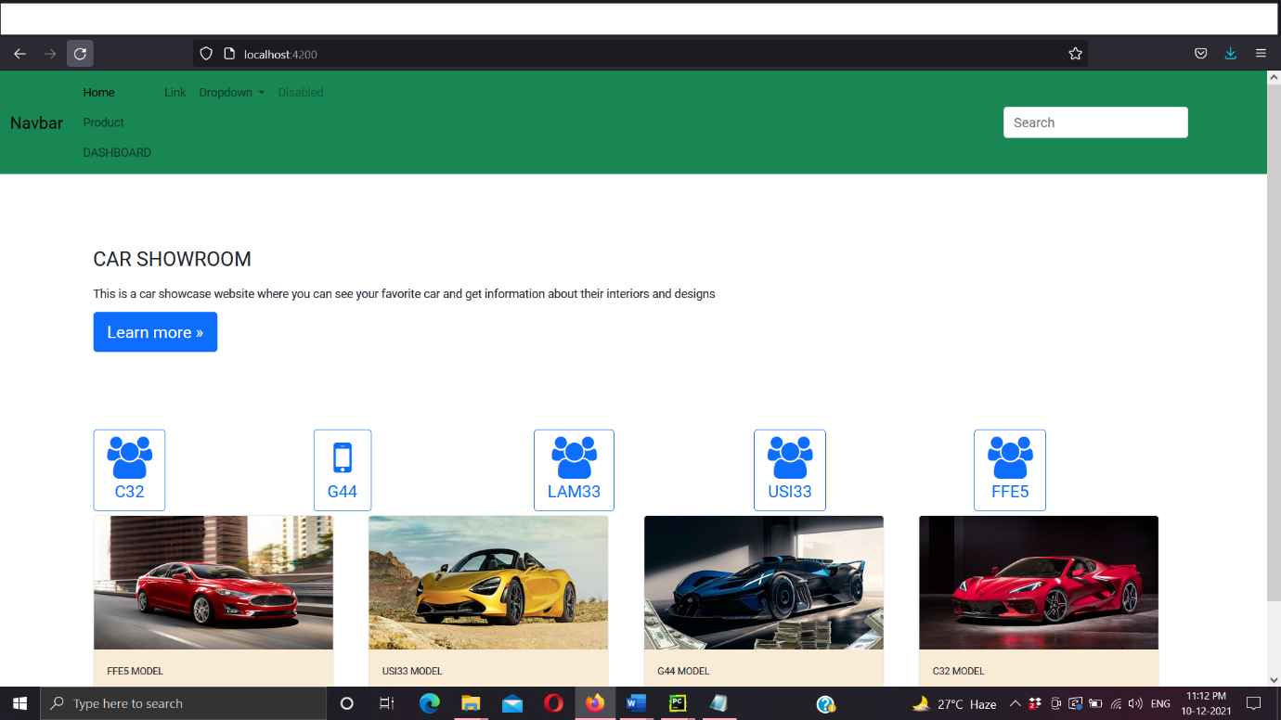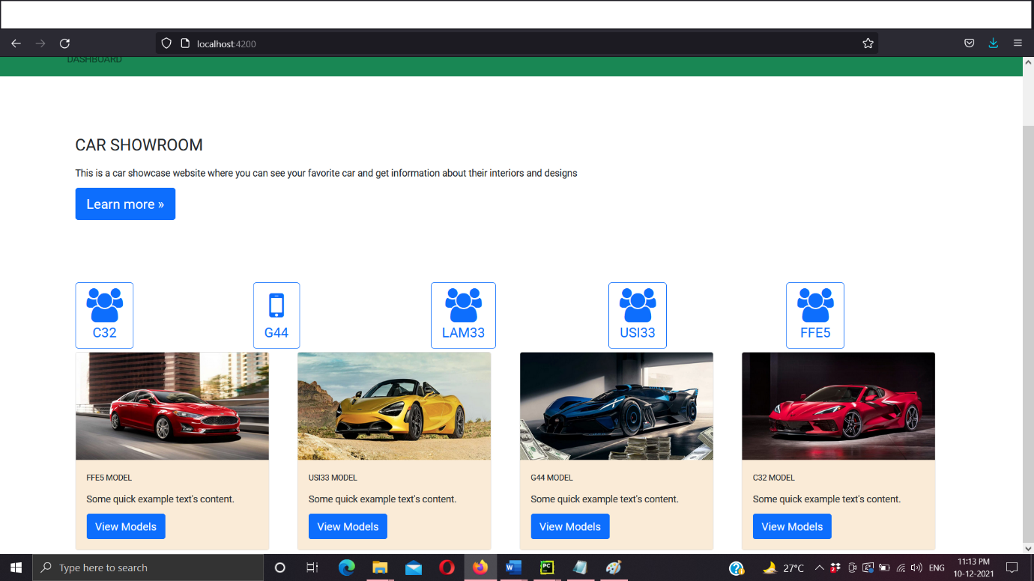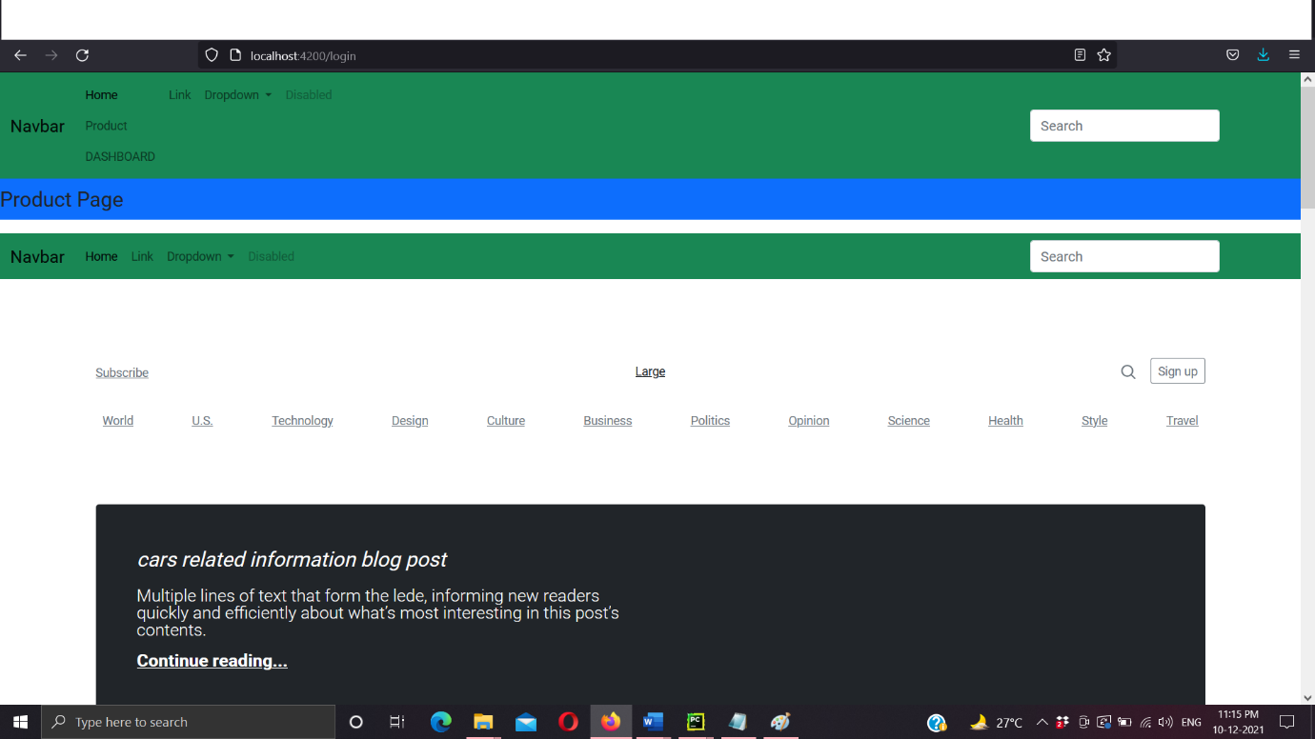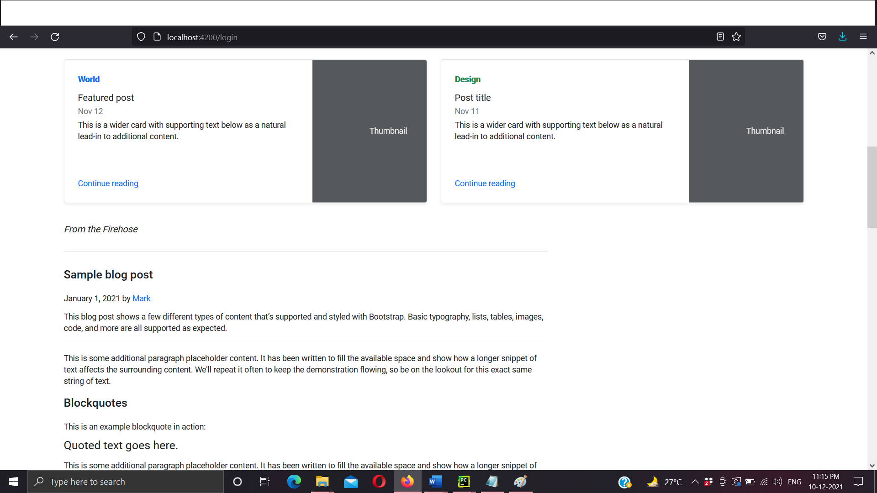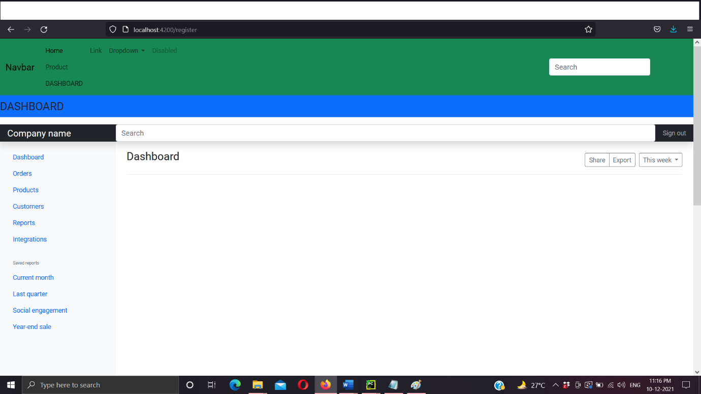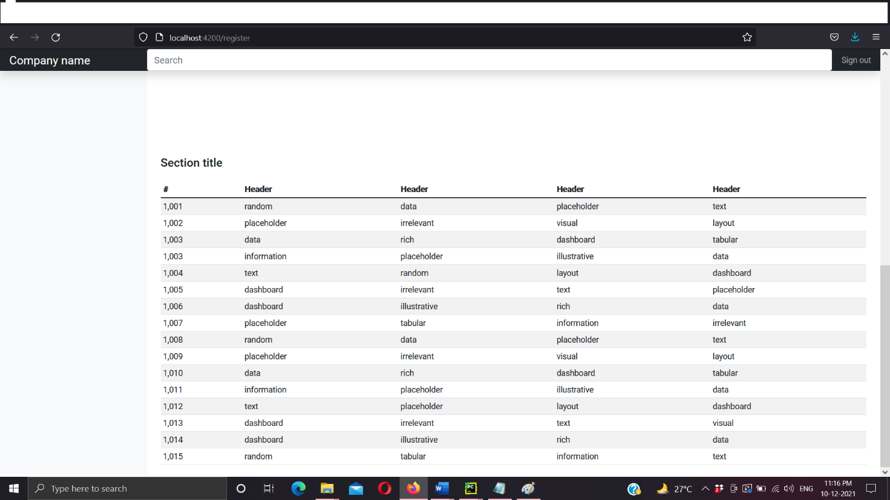

ADVANTAGES OF BOOTSTRAP

1. Fewer Cross browser bugs
2. A consistent framework that supports major of all browsers and CSS compatibility fixes
3. Lightweight and customizable
4. Responsive structures and styles
5. Several JavaScript plugins using the jQuery
6. Good documentation and community support
7. Loads of free and professional templates, WordPress themes and plugins
8. Great grid system

DISADVANTAGES OF BOOTSTRAP:

1. There will be requirement of lots of style overrides or rewriting files that can thus lead to a lot of time spent on designing and coding the website if the design tends to deviate from the customary design used in Bootstrap.
2. You would have to go the extra mile while creating a design otherwise all the websites will look the same if you don’t do heavy customization.
3. Styles are verbose and can lead to lots of output in HTML which is not needed.
4. JavaScript is tied to jQuery and is one of the commonest library which thus leaves most of the plugins unused.
5. Non-compliant HTML.

SUMMARY

Both Bootstrap and Foundation have their own pros and their own cons. So if you are a startup and don’t have the kind of money that you would want to spend on designers and developers, you should definitely use frameworks. It is inevitably more than an interim MVP arrangement, but as you scale you would require assistance from a WordPress development company.

Although before you hit the [PSD to Bootstrap](https://www.uplers.com/html-web-development/) or PSD to Foundation checkbox, take another look at the article and understand the advantages and the disadvantages of both Bootstrap and Foundation. And then you can choose what you want while developing a website based on the advantages you would need and what you would be ready to give up on.